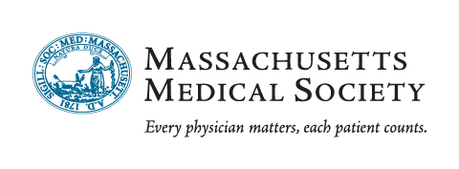
Group ID:

Resident-Fellows Program Free Enrollment

Enrollment Form for RENEWING Programs
- Thank you for taking the time to complete this form.
- Please include specific addressing information such as suite, floor, or mailstop.
- Any item that is marked with an asterisk (*) is required information.
- Please return this form and all trainees’ data to complete your renewal.

Program Information:

* Institution name:
* Program specialty:
* Address one:
* Address two:
* City * State: * Zip + Four: -

Program Details:

* Total number of trainees in your program: ACGME#:
This program consists of: Residents Fellows Combined (Residents and Fellows)
If this is a combined program with another institution, please indicate the institution below:

Program Coordinator Contact Information:

* Program Coordinator Name:
* Title:
* Telephone: Fax:
* Email address:
If Coordinator’s postal address is different from the program address, please list it below:

Program Physician Director Information:

* Program Director Name:
*Title: _______________________________________________________________________________________
* Telephone: Fax:
* Email address:

Chief Residents:

Chief Resident 1: Chief Resident 2:

I am confirming my group’s participation in the MMS 2017–2018 Resident/Fellows Group enrollment program.
Authorized Individual’s Name:

I understand that checking this box is the equivalent of my electronic signature. Date:
Please complete this form and email it AND your program roster to groups@massmed.org.
Questions? Contact us at groups@massmed.org or call (800) 322-2303, ext. 7748.
Massachusetts Medical Society 860 Winter Street, Waltham, MA 02451 (800) 322-2303 www.massmed.org



Dues-Exempt

Resident/Fellows Program Sample

Training Program Name:

Please include all of the information listed above for each physician on your roster and email completed roster to groups@massmed.org or fax to (781) 893-0413.

Please download an Excel template roster at www.massmed.org/residents/roster.

